

Technion- Israel Institute of Technology

Electrical and Computer Engineering

NSSL – Networked Software Systems Laboratory

Project Report

**IoT Communication Network**

**A computer network of tiny computers**

Ali Sweed and Suray Sweed

With supervisor Roy Mitrany

Winter 2022

Abstract

Many forests have been destroyed and harshly damaged because of the fire outbreak. As a result, a monitoring system to predict fire outbreaks and send a warning or image is needed. So, this project aims to establish and manage a network among tiny computers (esp32 cam boards) scattered in the forest. When an esp32 board detects a potential fire outbreak, an image is taken and derived through the esp’s network till arrived to the user.

The network established by the tiny computers is an ESP-MESH network, which contains mesh clients and one mesh root, the clients and the root are ESP32-CAM boards. The root got the warning image from one of the clients and send it to a server listening on the user’s computer.

The MESH network is established using the painlessMesh library, and the messages are sent in Jason format.

Table of contents

Table of figures

Table of abbreviations

IDE - Integrated Development Environment.

Node- Any device that can be part of a Mesh Network.

Root/Bridge Node- The top node in the network.

Introduction

The new era of the Internet of Things (IoT), has already arrived in corporate and home networks, as well as in video streaming, data transmission etc. IoT devices can easily be remotely controlled and monitored using wireless communication interfaces.

With the increase in the number of devices, it becomes difficult to maintain the availability of wireless networks due to increased mutual interference and noise, so the actual problem is to create mesh networks, where the node does not need to be connected to the switch.

Chapter1: Environments

Arduino environment:

The Arduino IDE environment is an open-source software platform used for programming and developing electronic projects. It provides an environment that users can use to write, compile, and upload code for Arduino boards.

Arduino environment is user-friendly and easy to use, so it's good for beginners and provides advanced features that fit more experienced users.

The environment includes an integrated development environment (IDE) that provides a text editor, code highlighting, and debugging tools. It also includes a set of libraries that provide pre-written code for commonly used functions, such as controlling LEDs or reading sensors

**Why Arduino?**

* The Arduino environment makes it easy for students and hobbyists to get started with electronics and programming.
* Using c language which is easy to use.
* Arduino environment is open source with a large community of users and developers contributing to its development. Also, it’s free to download.

References: chatgpt, nahdya project (Arduino environment and why arduino)

**Guide for using Arduino IDE:**

### A Typical Workflow

To upload code to an Arduino board using the IDE, one typically does the following:

**1. Install your board** - this means installing the right "package" for your board. Without the package, you can simply not use your board. Installing is done directly in the IDE, and is a quick and easy operation.

Tools -> boards -> chose a board.

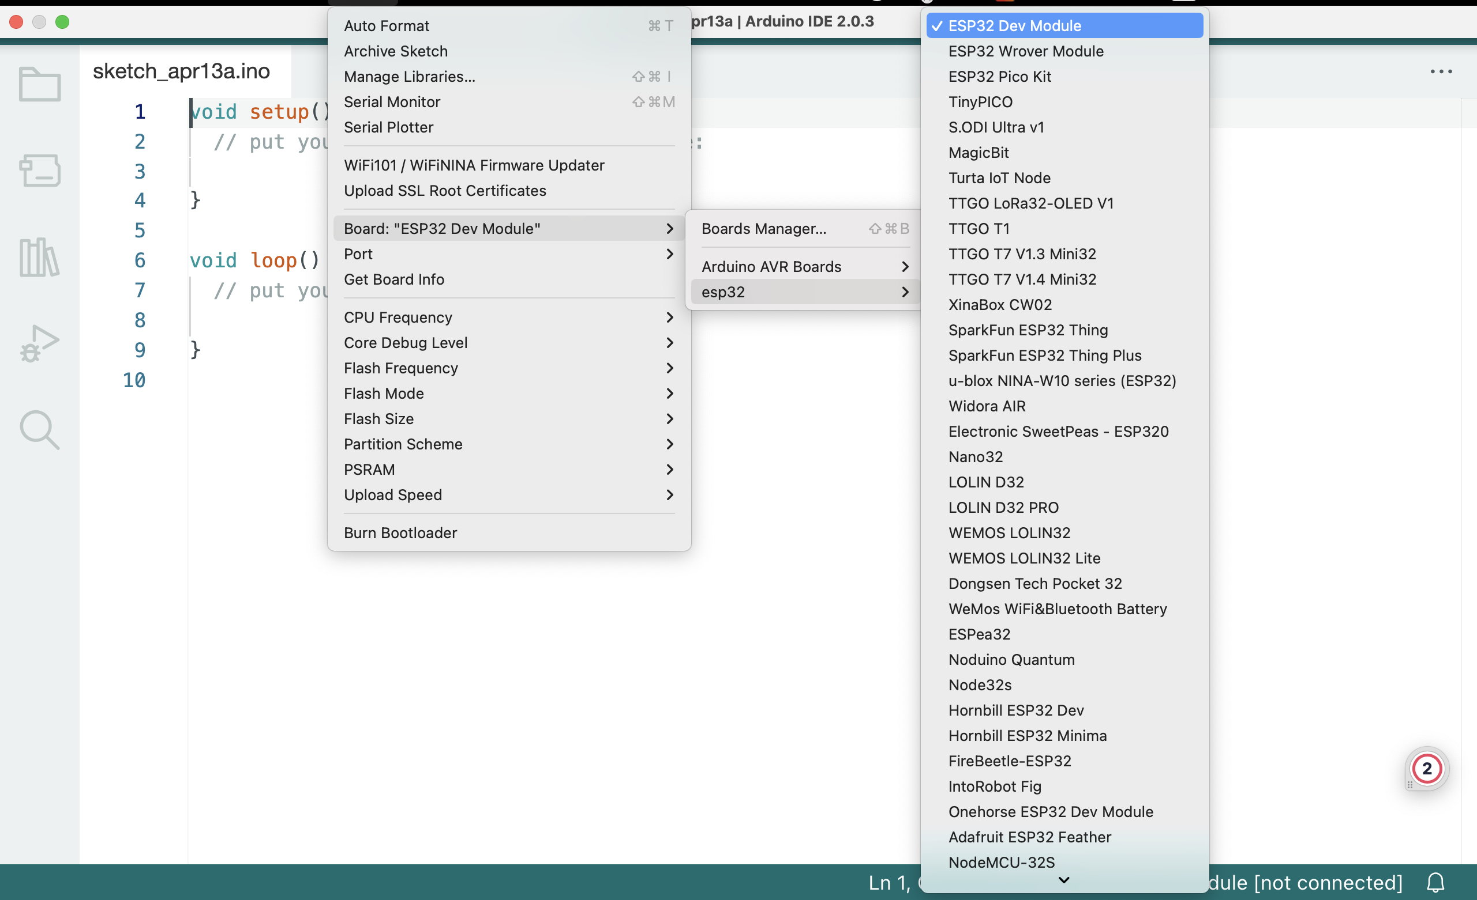

Figure 1: choosing a board in Arduino IDE

**2. Create a new sketch** - a sketch is your main program file. Here we write a set of instructions we want to execute on the microcontroller.

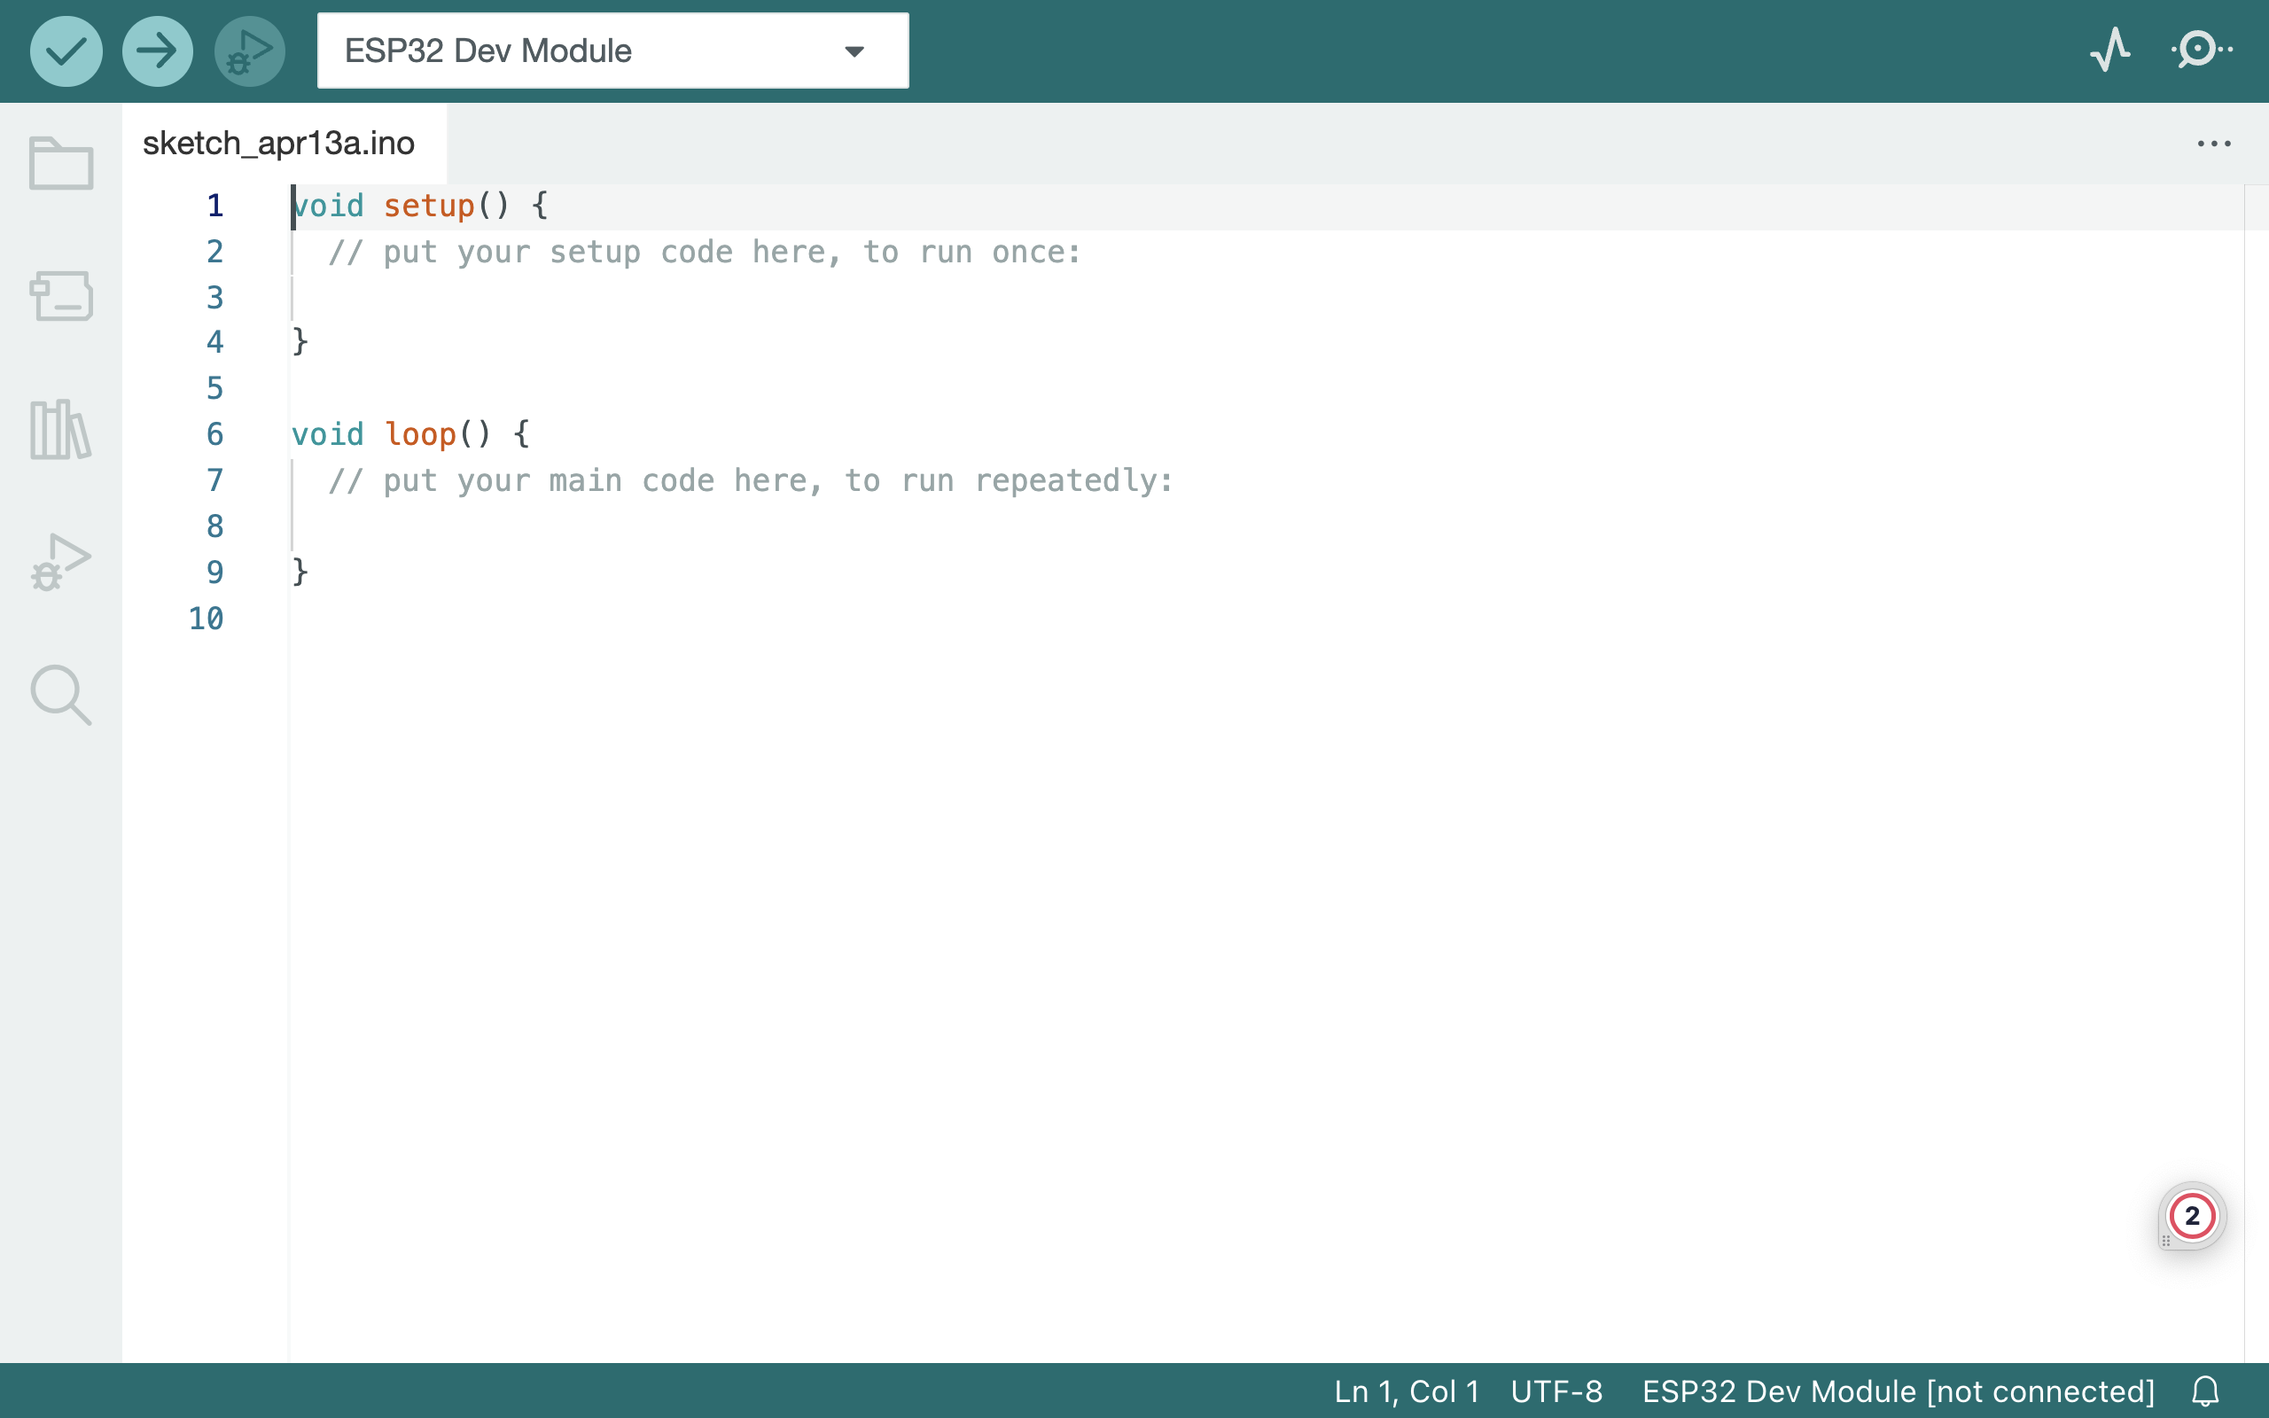

Figure 2: new sketch in Arduino IDE including the minimum two required functions

Void setup()  - this function executes only once, Here we define things such as the mode of a pin (input or output), the baud rate of serial communication, or the initialization of a library.

Void loop() - this is where we write the code that we want to execute over and over again.

**3. Compile your sketch** - the code we write is not exactly how it looks like when uploaded to our Arduino: compiling code means that we check it for errors, and convert it into a binary file (1s and 0s). If something fails, you will get this in the error console.

Compiling the sketch is done using the button.

**4. Upload your sketch** - once the compilation is successful, the code can be uploaded to your board. In this step, we connect the board to the computer physically and select the right serial port.

Tools -> port -> chose a port.

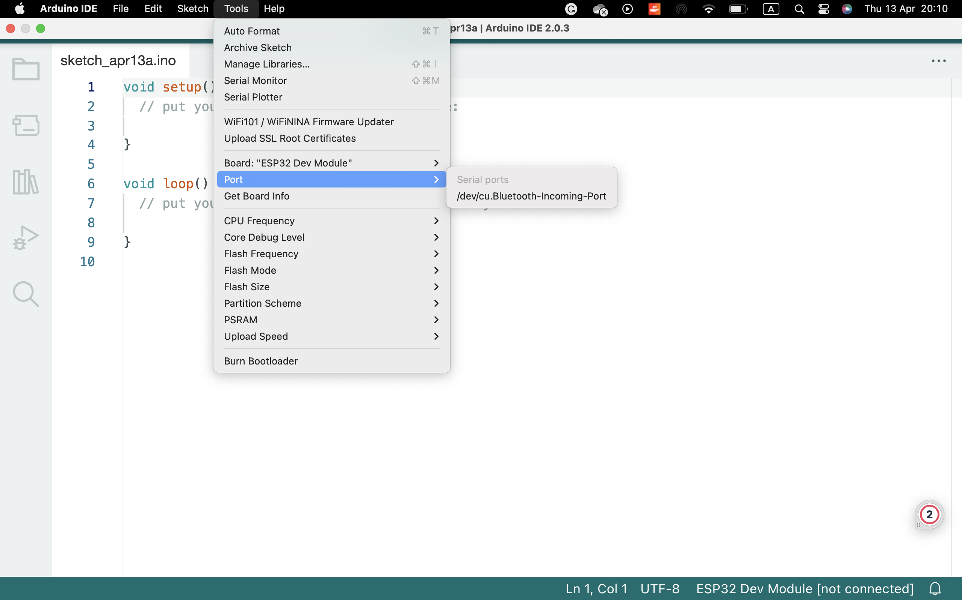

Figure 3: choosing a port for uploading in Arduino IDE



Uploading the code is done using the button.

**5. Serial Monitor (optional)** - for most Arduino projects, it is important to know what's going on on your board. The Serial Monitor tool available in all IDEs allows for data to be sent from your board to your computer.

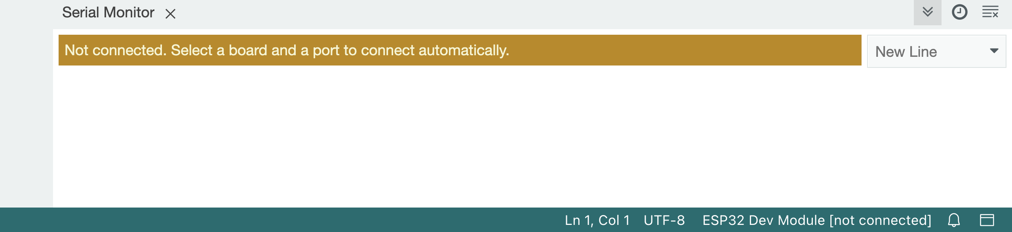

Figure 4: the serial monitor in Arduino IDE

Every version of the IDE has a library manager for installing Arduino software libraries. Thousands of libraries, both official and contributed libraries, are available for direct download.

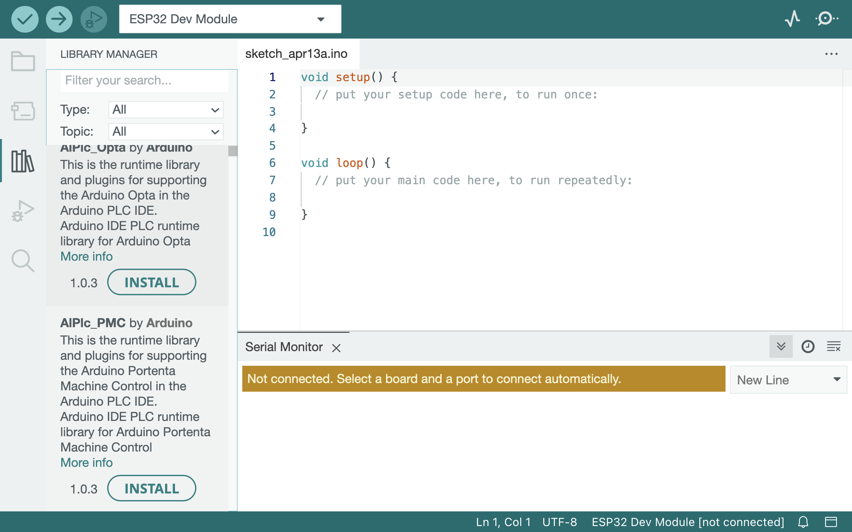

Figure 5: library manager for downloading libraries in Arduino IDE

The libraries we have used in the project:

* ArduinoJson.
* AsyncTCP.
* ESPAsyncTCP.
* Painless_Mesh.
* TaskScheduler.

Reference: <https://docs.arduino.cc/learn/starting-guide/getting-started-arduino>

Getting started with arduino

GitHub

GitHub Inc. is a web-based hosting service for version control using Git. It was founded in 2008 and is now owned by Microsoft. GitHub provides a platform for developers to collaborate on software projects by storing and managing code repositories, tracking changes to the code over time, and facilitating collaboration among team members.

In addition to hosting code repositories, GitHub provides a range of tools and features that support software development, including bug tracking, project management, code review, and more. GitHub has become a popular platform for open-source software development, with millions of users around the world contributing to a vast array of projects.

Reference: chatgpt

Chapter 2: Building the hardware circuit

2.1 Introduction- The hardware circuit

The software is tested on a simple circuit using the following components:

* Number of ESP32-CAM.

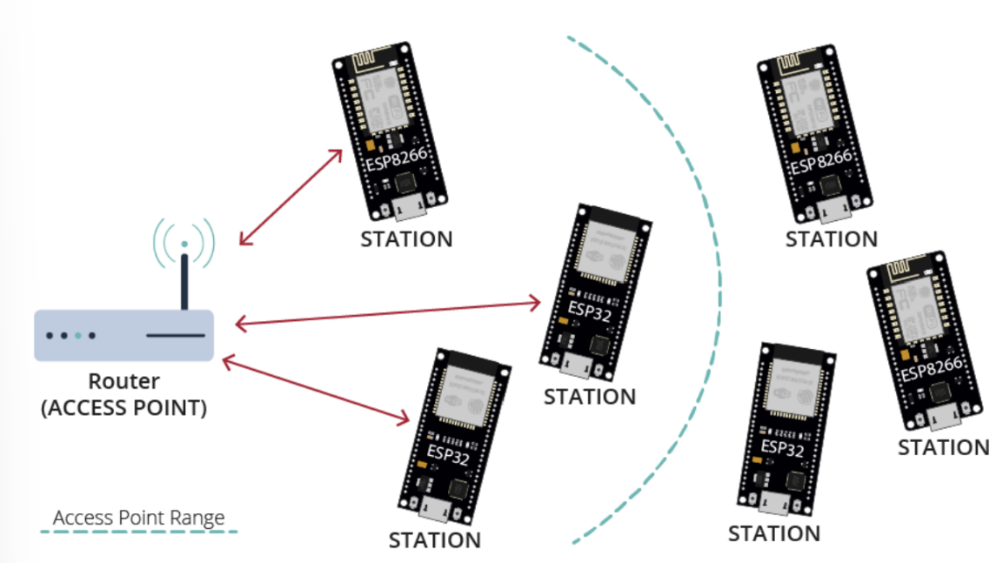

Figure 6: The HW circuit

2.2 The processor- ESP32-CAM

2.1.1 The processor ESP32

ESP32 is a powerful SoC microcontroller with integrated Wi-Fi, dual mode Bluetooth version 4.2 and a variety of peripherals. It is equipped with 4MB of flash memory. The ESP32 chip has been developed by Espressif Systems, which currently offers several ESP32 versions of the SoC in the form of ESP32 Developer Kit, the ESP32 Wrover Kit which also includes an SD card and 3.2 '' LCD display, and finally the ESP32 Azure IoT kit with USB Bridge and other built-in sensors. The ESP32 device can be programmed using any Windows, Linux, or MacOS operating system. The easiest way to start writing code for the ESP32 platform is to use the Arduino platform. The main advantages of using ESP32 chip include wide deployment capabilities, support for Wi-Fi standards and protocols, Bluetooth communication, and low-cost solutions.

2.1.2 The processor ESP32-CAM

The ESP32-CAM is a popular development board that combines ESP32 microcontroller with a camera module, making it capable of capturing images and streaming video over a network. It offers a cost-effective and versatile solution for projects requiring camera functionality and wireless communication.

In addition, ESP32-CAM comes with an OV2640 camera module that features a 2MP (megapixel) image sensor. It supports various resolutions and formats, including JPEG, BMP, YUV, and RGB. The camera module connects to the ESP32 via the Serial Camera Control Bus (SCCB) interface.

ESP32-CAM is suitable for a wide range of applications, such as surveillance systems, video streaming, home automation robotics and IoT projects. Its compact size and low power consumption make it ideal for embedded and portable devices.

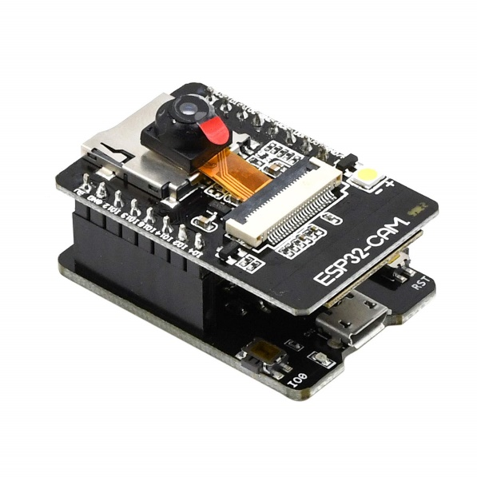

Figure 7: ESP32-CAM processor

**Pin layout:**

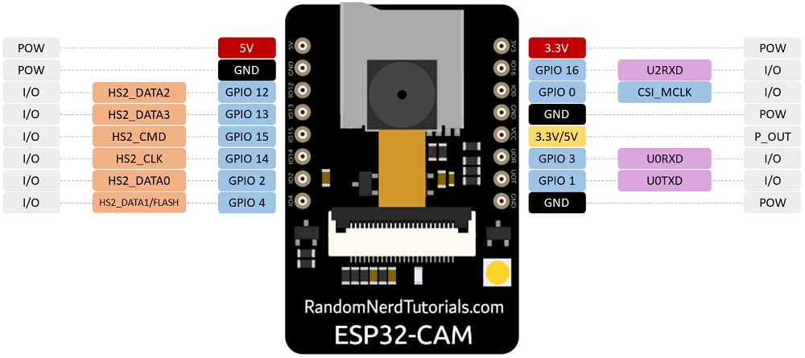

Figure 8: ESP32-CAM pins layout

There are three GND pins and two pins for power: either 3.3V or 5V.

GPIO 1 and GPIO 3 are the serial pins. You need these pins to upload code to your board. Additionally, GPIO 0 also plays an important role, since it determines whether the ESP32 is in flashing mode or not. When GPIO 0 is connected to GND, the ESP32 is in flashing mode.

The following pins are internally connected to the microSD card reader:

* GPIO 14: CLK
* GPIO 15: CMD
* GPIO 2: Data 0
* GPIO 4: Data 1 (also connected to the on-board LED)
* GPIO 12: Data 2
* GPIO 13: Data 3

Chapter 3: Wireless Mesh Network

3.1 Abstract-:

A wireless mesh network (WMN) is a type of mobile ad hoc network (MANET), which provides access to many users covering a wide area. MANET is formed dynamically by mobile devices with no need for infrastructure or prior network configuration. Like MANET, WMN has the abilities of self-organizing, self-discovering, self-healing, and self-configuration. However, WMN contains mesh routers (MRs), some of them have wired connection and acts like gateways to provide an internet connection to the mesh network.

3.2 Introduction-

Mesh networking is the local network topology in which nodes are directly and dynamically connected spread over a large physical area. The nodes communicate with one another to efficiently send the data from/to clients. Because of that, the whole network does not rely on one node only. As a result, the large number of nodes can be connected to the Internet without adding routers to the network. Mesh networking contain an auto-networking functionality which means that when the user sets up a mesh network, any node can scan the access point and connect easily.

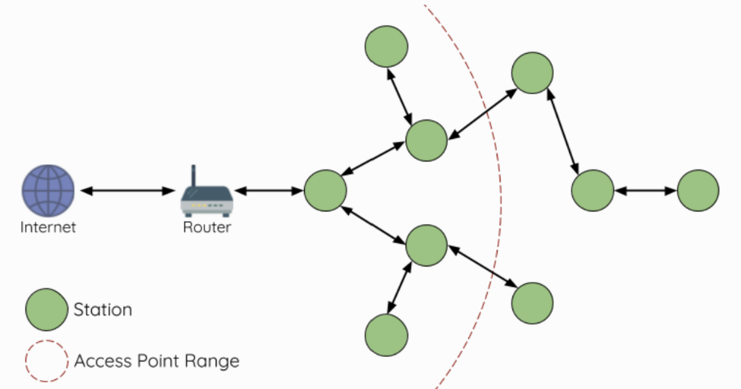

Figure 9- Mesh Network Architecture

The MANET was initialized by the defense advanced research projects agency around 30 years ago for military uses in most cases. Recently, WMN emerged as a multi-hop ad hoc network to provide Internet access for communities, enterprises, and cities.

In comparison to pure MANET, WMN has a hierarchical structure that includes two parts as shown in Figure 2:

1. Mesh backbone which contains the MRs. These MRs interconnect through single/multi-hop wireless links forming the backbone. Some of these MRs are wirely connected to the internet.
2. Mesh clients, which are mobile wireless devices such as cellphones and laptops. The mesh clients connect to any MR to receive internet services.

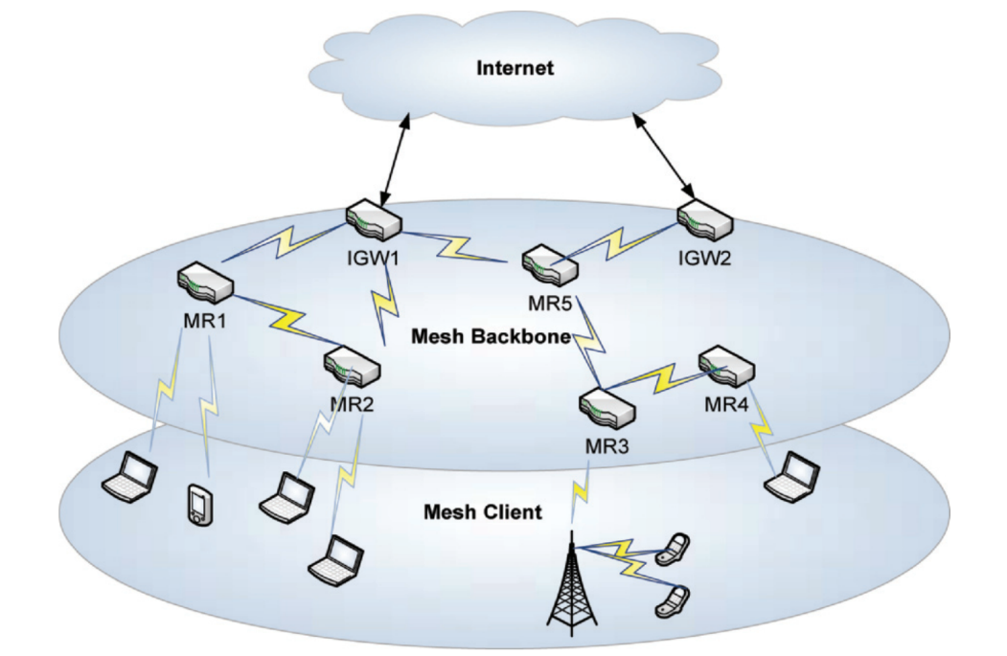

Figure 10: A typical architecture of WMN

Mesh backbones topology is relatively stable and supplies a cost-efficient way to access the internet compared to traditional wired and wireless networks such as WI-FI. This is because of the reduced dependence on infrastructure and multi-hop routing.

MANET’s main characteristic (which is also available in WMN):

* **Self-forming, self-configuring, and self-healing:** the network is established spontaneously, and the multi-hops communications are managed without any centralized network authority.
* **Dynamic topology:** the topology of MANET changes permanently because of the device’s mobility, new node’s enrollment, and some nodes leave without prior notification.
* **Constrained resources:** the nodes are usually powered by a battery to receive and send packets to other nodes, so they work for a limited period.

From MANET to WMN:

While MANET faced problems to supply internet service to its nodes, WMN supplies internet services by MRs forming the mesh backbone, so mesh clients (mobile devices) can access the internet via these MRs. A MR not only handles the packets that arrived from its clients but also relays the traffic from other MRs, so a client can access the internet through a multi-hop manner. As a result, the installation cost of the whole system will be reduced.

Main improvements of WMN over MANET:

* Infrastructure support of MANET: as said before, MANET clients haven’t internet access. On the contrary, MRs that are connected to the internet forming internet gateways (IGs) provide internet accessibility for mesh clients.
* Minimal mobility of MRs in a WMN: each MR is situated in a fixed position, like the roof of a building, and has minimum mobility, therefore the topology of the backbone is fixed unless a new enrolling of MR happened or any MR leaves. This is important for reducing the probability of link breakage and for the improvement of the network throughput.
* Rich energy of MR: in WMN each MR is connected to a rich power supply unlikely MANET which suffers from energy constraints.
* Multi-radio and multichannel: each MR in WMN can use multiple orthogonal channels so the network bandwidth is improved. This is abled because MRs can simultaneously transmit/receive packets in multiple radios without interference with each other.

Some of WMN's benefits (why WMN):

* **High-speed wireless system:** the wireless backbone of the WMN provides internet accessibility for mesh clients. IEEE 802.11g and 802.11n wireless protocols provide high-speed connectivity in the 2.4 GHz band, with data rates of up to 54 Mbps and between 100-200 Mbps respectively. These high rates are enabled by advanced physical layer technology such as modulation coding schemes and multiple input/output. The wireless backbone can support real-time commercial applications and bandwidth-consuming communication needs, and its capacity can be improved by deploying multiple orthogonal channels and infrastructure consisting of IGWs nodes. As the MRs number that performs as IGWs rise the network capacity is improved.
* **Promising coverage and connectivity:** in pure MANET, internet accessibility isn’t available due to its infrastructure-less nature. In a wireless local area network (WLAN) each device is connected directly to the access point using centralized medium access. Therefore, WLAN coverage is a limited area, and the connectivity is only available in a single hop range. In wireless personal area network (WPAN (, a high-speed data transmission is provided but it’s for a short range because of limited transmission power and its operating frequency band. In WMN, each MR serves as both a host for its associated mobile clients and a router to forward packets on behalf of other MRs. As a result, WMN covers a wide area and supplies connectivity for many clients using multi-hop fashion. Additionally, mobile devices can quickly transition in the WMN from one accessing MR to another using an appropriate migrating scheme.
* **Flexible and cost-efficient:** WMN can be constructed and managed by one single internet service provider (ISP), or the core MRs can be controlled by one or several ISPs while other MRs can be added by users, which is called seme managed WMN. Moreover, a WMN can be operated in an unmanaged way where each MR is managed independently. Regardless of the commercial operating model, an MR can be added to WMN or uninstalled from it using the self-configuration and self-forming capabilities. Internet accessibility is achieved using IGWs, which reduced the need for expensive links and hardware. For those reasons, WMN is a cost-efficient solution for mobile users.

Reference: book: “guide to wireless mesh network”, chapter 1, pages 17-23

3.3 IEEE 802.11s Wireless Mesh Network Standard -

IEEE 802.11s standard defines a hybrid wireless mesh protocol (HWMP) that combines the flexibility of reactive on-demand route discovery and the efficiency of proactive routing. The reactive on-demand mode in HWMP is based on the Radiometric ad-hoc on-demand distance vector (RM-AODV) protocol, while the proactive mode is implemented by tree-based routing. This combination can achieve optimal and efficient routing selection.

Moreover, the standard determines the HWMP information elements which are path request (PREQ), path reply (PREP), path error (PERR), and root announcement (RANN). This information is used to propagate metric information among the mesh STAs and determines the cost of links in the network.

The metric cost of links is used in HWMP to determine which path to build. HWMP can support various radio metrics in path selection, such as throughput, quality of service (QoS), load balancing, power awareness, and more. The default metric is the airtime cost metric, which considers the PHY and MAC protocol overhead, frame payload, and the packet error rate to reflect the radio link condition.

The airtime cost of each link $C_{a}$ is given by:

$$C_{a}=\left[O+\frac{B_{t}}{r}\right]\frac{1}{1-e_{f}}$$

When:

* $O and B_{t}$ are constants for each 802.11 modulation type.
* r is the data rate in Mb/s.
* $e_{f}$ is the frame error rate in Mb/s for the test frame with size $B_{t}$.

Reference: mobile lightweight wireless system pages: 276-278 + 280

**HWMP elements:**

* RANN (broadcast): tells MPs about the presence and distance of Root MP.
* PREQ (broadcast/unicast): ask destination MP(s) to form a reverse route to the originator
* PREP (unicast): forms a forward route to the originator and confirms the reverse route.
* PERR (broadcast): tell receiving MPs that the originator no longer supports certain routes.

**On-demand routing-based RM-AODV:**

* Based on basic mandatory features of AODV (RFC 3561)
* Extensions to identify best-metric path with arbitrary path metrics
* Destinations may be discovered in the mesh on-demand

**Route discovery:**

* Uses Expanding Ring Search to limit the flood of routing packets
* Reverse Paths are setup by Route Request (Path Request) packets broadcast (or unicast) from the Originator
* Forward Paths are setup by Route Reply (Path Reply) packet sent from the destination node or any intermediate node with a valid route to the destination

**Route maintenance:**

* Nodes monitor the link status of the next hops in active routes. When a link break in an active route is detected, a Route Error (Path Error) message is used to notify other nodes that the loss of that link has occurred.
* Route Error message is a unicast message, resulting in quick notification of route failure.

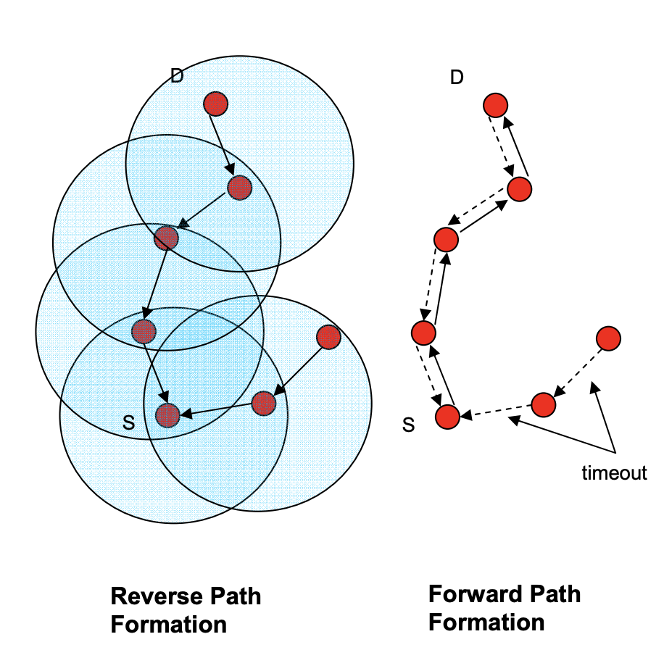

Figure 11: On-demand routing in HWMP

**Proactive routing based on tree-based routing:**

* If a Root portal is present, a distance vector routing tree is built and maintained
* Tree-based routing is efficient for hierarchical networks
* Tree-based routing avoids unnecessary discovery flooding during discovery and recovery

**Topology creation:**

* Root MP may issue a “broadcast” PREQ, MPs may respond with PREP
* The Root MP may issue “Root Announcements”, MPs may respond by a unicast PREQ to the Root (answered by PREP)
* MPs select the next hop to Root based on the best path metric, Best path propagates down from the Root (e.g. X-4-2-1)
* “Registration” of subtrees by MPs facilitates outward message routing

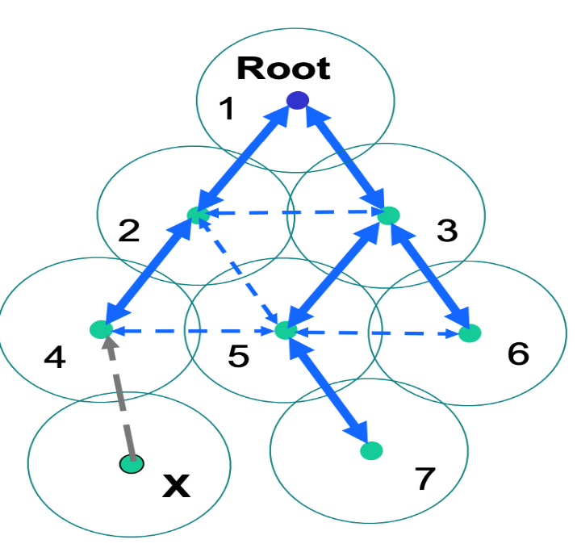

Figure 12: Topology creation based on the tree-based routing

**Topology maintenance:**

* MPs monitor their upstream links and may switch to backup links using RREP (3-1 >> 3-2) This avoids “re-building” the tree
* Loss of upstream link causes RRER to be sent down. Allows nodes to decide/select their own back-up paths. Signals route holders that some route is broken

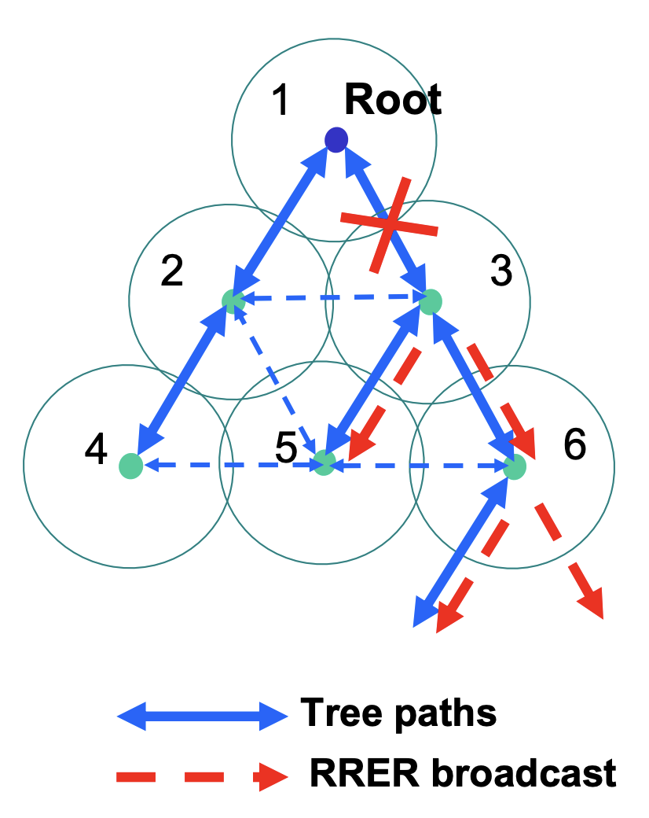

Figure 13: topology maintenance (sending PERR broadcast)

Reference: IEEE 802.11s tutorial pages 37-47.

3.4 PainlessMesh Library- ESP Mesh Wi-Fi

3.4.1 Introduction-

PainlessMesh is a Wi-Fi mesh network library specifically written for the ESP32-cam platforms and is actively maintained by the community. The library is written in c++ language. It is called PainlessMesh for it is intended to be auto-configure and easy to setup. It is an ad-hoc network which requires neither routing plan nor central controller and all nodes are equal.

The painlessMesh library is unique for it enables the resource limited ESP32-cam device to form a mesh network. Two or more modules, also called nodes, with the same SSID (service set identifier) will be automatically connected to form a mesh network. In the painlessMesh network, each node can serve as both an access point for other nodes to connect to, and also a station connecting to another node. Every node is aware of the whole network topology which is updated periodically every 3 seconds. Every node tells its neighbors about other nodes it is directly or indirectly connected to. A node’s station which is not connected to any access point will actively look for an access point that has the strongest signal but is not listed yet in its network topology. This mechanism prevents the formation of cyclic paths. So there will be only a single path between a pair of nodes.

The painlessMesh works on layer 3 of the OSI Model- Network layer but not based on IP addressing. Instead, each node is distinguished by a unique 32-bit number taken from chip MAC address. Communication in the mesh is done via JSON formatted messaging. Although it is less efficient than low level binary messaging, it is easier for users to understand and to incorporate in JavaScript or web applications. There are two types of user message, i.e., single and broadcast message. Single message is sent from a node to another specific node, whereas broadcast message is addressed to all other nodes connected in the network. All nodes are time synchronized with a precision of less than 10 Ms. This is useful for the nodes to run synchronous tasks. Mesh network offers its usefulness by allowing a collection of ESP32-cam nodes to cover larger area through multi-hop messaging. Any nodes within reachable range will be automatically forming a mesh network. Therefore, the mesh network also leverages the network reliability by automatically joining to a neighboring network in the event of disconnection.

3.4.2 Node Types

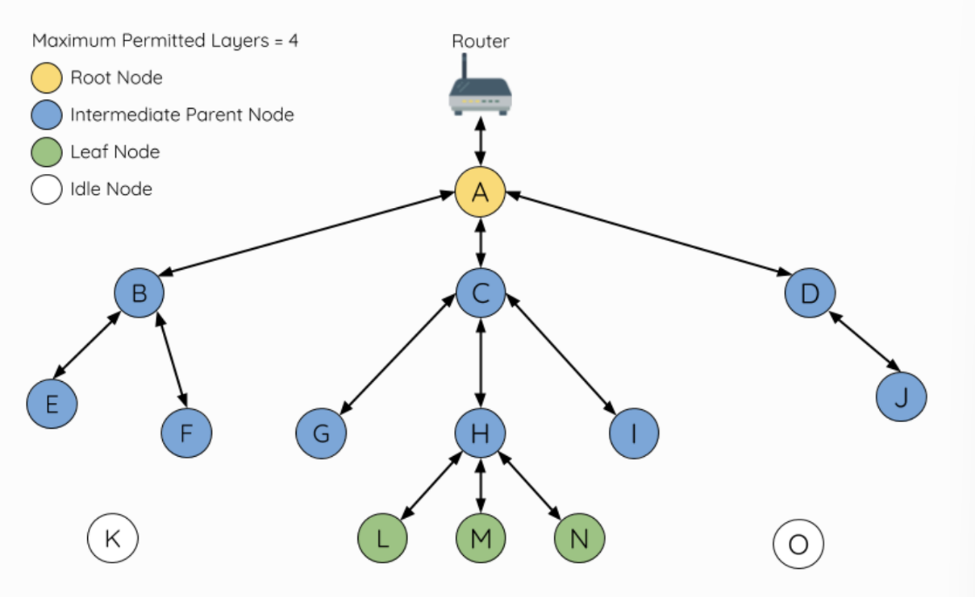

Figure 14- Mesh Network Node Types

**Root Node:** The root is the top node in the network and serves as the only interface between ESP-WIFI-MESH network and an external IP network. The root node is connected to a conventional Wi-Fi router and relays packets to/from the external IP network to nodes within the ESP-WIFI-MESH network. There can be one root node within an ESP-WIFI-MESH network and the root node's upstream connection may only be with the router.

**Leaf Nodes:** a leaf node is a node that is not permitted to have any child nodes. Therefore a leaf node can only transmit or receive its own packets, but cannot forward the packets of other nodes.

**Intermediate Parent Nodes:** Connected nodes that are neither the root node or a leaf node are intermediate parent nodes. Therefore, an intermediate parent node can transmit and receive packets, but also forward packets sent from its upstream and downstream connections.

**Idle Nodes:** Nodes that have yet to join the network are assigned as idle nodes.

3.4.3 Preferred Parent Node

When an idle node has multiple parent nodes candidates (potential parent nodes), the idle node will form an upstream connection with the preferred parent node. The preferred parent node is determined based on the following criteria:

* Which layer the parent node candidate is situated on.
* The number of downstream connections (child nodes) the parent node candidate currently has.

If there are multiple parent node candidates within the same layer, the parent node candidate with the least child nodes will be preferred. This criteria has the effect of balancing the number of downstream connections amongst nodes of the same layer.

3.4.4 Routing Tables

Each node within a mesh network will maintain its individual routing table used to correctly route the mesh network packets to the correct destination node. The routing table of a particular node will consist of the MAC addresses of all nodes within the particular node's subnetwork.

Mesh network utilizes routing tables to determine whether an mesh network packet should be forwarded upstream or downstream based on the following rules:

* If the packet’s destination MAC address is within the current node’s routing table and is not the current node, select the sub table that contains the destination MAC address and forward the data packet downstream to the child node corresponding to the sub table.
* If the destination MAC address is not within the current node’s routing table, forward the data packet upstream to the current node’s parent node. Doing so repeatedly will result in the packet arriving at the root node where the routing table should contain all nodes within the network

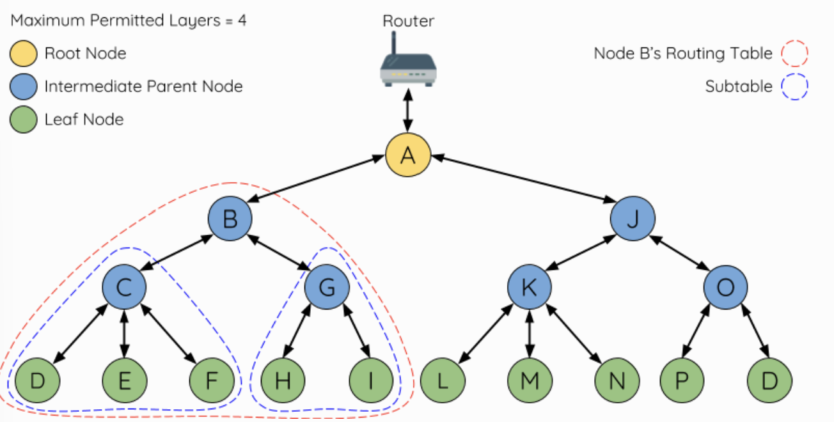

Figure 15: ESP-WIFI-MESH Routing Tables Example

3.4.5 Building a Network

An ESP-WIFI-MESH network building process involves selecting a root node, then forming downstream connections layer by layer until all nodes have joined the network. The exact layout of the network can be dependent on factors such as root node selection, parent node selection, and asynchronous power-on reset. However, the ESP-WIFI-MESH network building process can be generalized into the following steps:

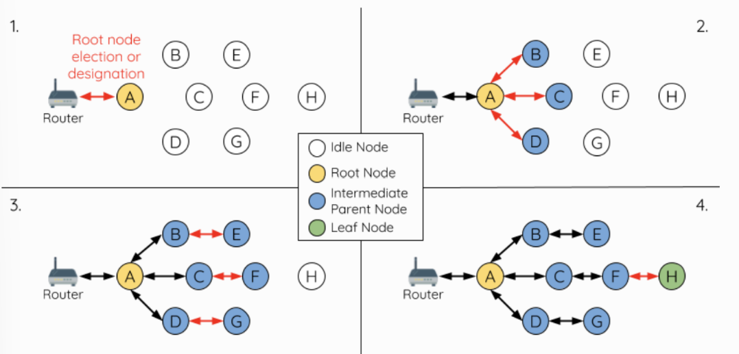

Figure 16: ESP-WIFI-MESH Network Building Process

1. **Root Node Selection:** The root node can be designated during configuration or dynamically elected based on the signal strength between each node and the router. Once selected, the root node will correct with the router and begin allowing downstream connections to form.
2. **Second Layer Formation:** Once the root node has connected to the router, idle nodes in range of the root node will begin connecting with the root node thereby forming the second layer of the network. Once connected, the second layer nodes become intermediate parent nodes hence the next layer to form.
3. **Formation of remaining layers:** The remaining idle nodes will connect with intermediate parent nodes within range thereby forming a new layer in the network. Once connected, the idles nodes become intermediate parent node or leaf nodes depending on the networks maximum permitted layers. This step is repeated until there are no more idle nodes within the network or until the maximum permitted layer of the network has been reached.
4. **Limiting Tree Depth:** To prevent the network from exceeding the maximum permitted number of layers, nodes on the maximum layer will automatically become leaf nodes once connected. This prevents any other idle node from connecting with the leaf node thereby prevent a new layer form forming. However, if an idle node has no other potential parent node, it will remain idle indefinitely. Referring to the figure above, the network’s number of maximum permitted layers is set to four. Therefore, when node H connects, it becomes a leaf node to prevent any downstream connections from forming.

3.4.6 User Designated Root Node

The root node can also be designated by user which will entail the designated root node to directly connect with the router and skip the election process.

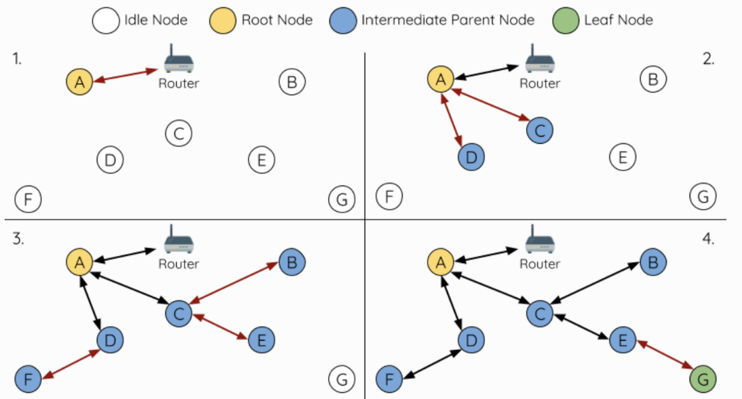

Figure 17: ESP-WIFI-MESH Root Node Designation (Root Node = A, Max Layers =4)

1. Node A is designated the root node by the user and all the other nodes skip the election process.
2. Nodes C/D connect with node A as their preferred parent node, both nodes from the second layer of the network.
3. Likewise, nodes B/E connect with node C and node F connects with node D. Nodes B/E/F from the third layer of the network.
4. Node G connects with node E forming the fourth layer of the network. However, the maximum permitted number of layers in this network is configured as four, therefor node G becomes a leaf node to prevent any new layers from forming.

3.4.7 Data Transmission

3.4.7.1 Esp Wi-Fi Mesh Packet

Mesh network data transmissions use ESP Wi-Fi Mesh packets. These packets are entirely contained within the frame body of a Wi-Fi data frame. During a multi-hop data transmission within the mesh network, each wireless hop involves the packet being carried by a different Wi-Fi data frame.

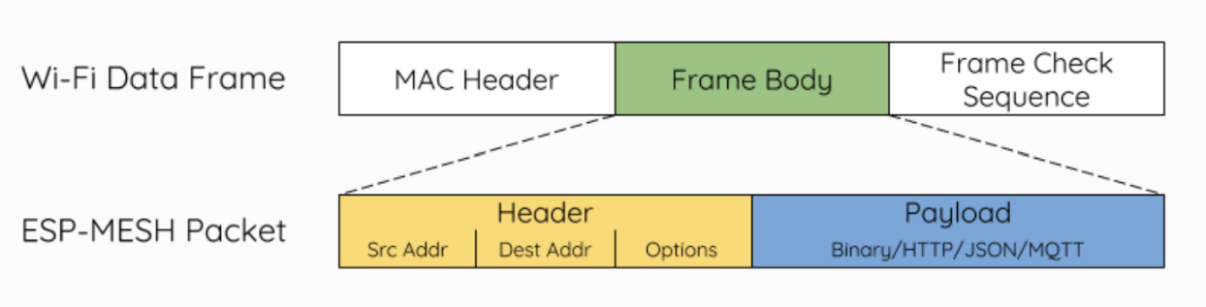

Figure 18ESP-WIFI-MESH packet and its relation with a Wi-Fi data frame

* The header of this packet contains the MAC addresses of the source and destination nodes. The options field contains information pertaining to the special types of these packets such as a group transmission or a packet originating from the external IP network.
* The payload of this packet contains the actual application data. This data can be raw binary data or encoded under an application layer protocol such as HTTP, MQTT and JSON.

3.4.7.2 Group Control and Multicasting

Multicasting is a feature that allows a single packet to be transmitted simultaneously to multiple nodes within the network. Multicasting in mesh network can be achieved by:

1. Multicasting with the Multicast-Group Address:

* Set the destination address of packet to the Multicast-Group Address (01:00:5E:xx:xx:xx). This indicates that the packet is a multicast packet with a group of addresses, and the specific addresses should be obtained from the header options.
* List the MAC addresses of the target nodes in the options field of the packet header. Each target node's MAC address needs to be individually listed in the options field. However, this method incurs overhead data due to the inclusion of MAC addresses.

1. Multicasting with preconfigured groups:

* Create preconfigured groups by assigning a unique ID to each group. Which places a node into a specific group.
* Set the destination address of the ESP-WIFI-MESH packet to the target group ID. This indicates that the packet is intended for multicasting to a specific group.
* With this method, nodes must be added to the appropriate groups beforehand. While it requires prior configuration, it incurs fewer overhead data compared to listing individual MAC addresses.

3.4.7.3 Broadcasting

Broadcasting is a feature that allows a single packet to be transmitted simultaneously to all nodes within the network. Each node essentially forwards a broadcast packet to all of its upstream and downstream connections such that the packet propagates throughout the network as quickly as possible.

In ESP-WIFI-MESH, specific methods are implemented to optimize bandwidth usage during broadcast transmissions:

1. Intermediate Parent Node Receiving Broadcast from Parent: when an intermediate parent node receives a broadcast packet from its parent, it will forward the packet to each of its child nodes while storing a copy of the packet for itself.
2. Intermediate Parent Node as the Source of Broadcast: When an intermediate parent node is the source of the broadcast, it transmits the broadcast packet upstream to its parent node and downstream to each of its child nodes. This ensures the broadcast reaches all nodes in its subtree.
3. Intermediate Parent Node Receiving Broadcast from Child: When an intermediate parent node receives a broadcast packet from one of its child nodes, it will forward the packet to its parent node and each of its remaining child nodes while storing a copy of the packet for itself.
4. Leaf Node as the Source of Broadcast: When a leaf node is the source node of a broadcast, it will directly transmit the packet to its parent node.
5. Root Node as the Source of Broadcast: When the root node is the source node of a broadcast, the root node will transmit the packet to all of its child nodes.
6. Root Node Receiving Broadcast from Child: When the root node receives a broadcast packet from one of its child nodes, it will forward the packet to each of its remaining child nodes whilst storing a copy of the packet for itself.
7. Discarding Broadcast Packets with Matching Source MAC: When a node receives a broadcast packet with a source address matching its own MAC address, the node will discard the broadcast packet.
8. Intermediate Parent Node Discarding Broadcast from Parent: When an intermediate parent node receives a broadcast packet from its parent node which was originally transmitted from one of its child nodes, it will discard the broadcast packet

3.4.7.4 Bi-Directional Data Stream

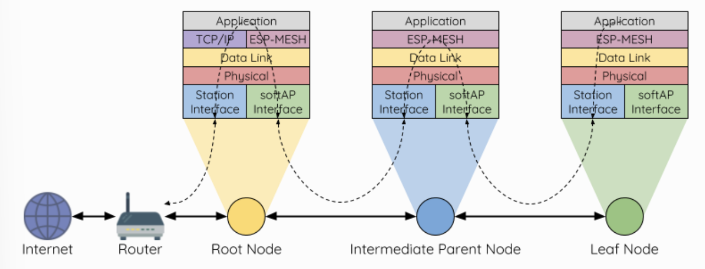

Figure 19: ESP-WIFI-MESH Bi-Directional Data Stream.

A TCP/IP layer is only required on the root node when it transmits a packet to an external IP network.

3.4.8 Esp Wi-Fi Mesh programming

3.4.8.1 Software Stack

The ESP-WIFI-MESH software stack is built atop the Wi-Fi Driver and may use the LwIP Stack in some instance (i.e., the root node). The following diagram illustrates the ESP-WIFI-MESH software stack.

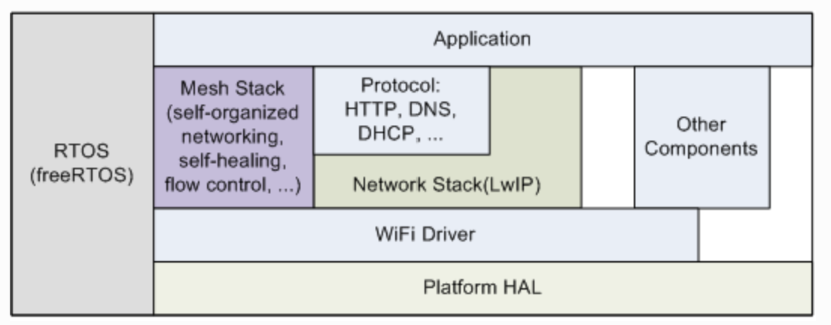

Figure 20: ESP-WIFI-MESH Software Stack

3.4.8.2 System Events

An application interface with ESP-WIFI-MESH via ESP-WIFI-MESH Event. Since ESP-WIFI-MESH is built atop the Wi-Fi stack, it is also possible for the application to interface with the Wi-Fi driver via the Wi-Fi Event Task. The following diagram illustrates the interfaces for the various System Events in an ESP-WIFI-MESH application.

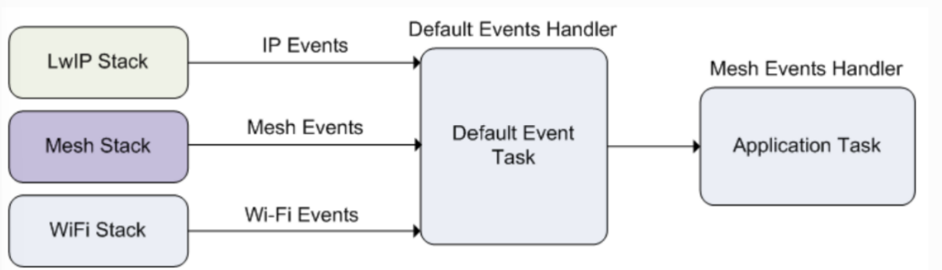

Figure 21: ESP-WIFI-MESH System Event Delivery

Typical use cases of mesh events include using events such as:

* MESH_EVENT_PARENT_CONNECTED.
* MESH_EVENT_CHILD_CONNECTED.
* IP_EVENT_STA_GOT_IP.
* IP_EVENT_STA_LOST_IP.

3.4.8.3 LwIP & ESP-WIFI-MESH

LwIP (Lightweight IP) is an open-source TCP/IP networking stack that is widely used in embedded systems and microcontrollers. It provides a lightweight implementation of the IP protocols, including IP, TCP, UDP, and ICMP. LwIP is designed to be memory-efficient and requires relatively low processing power, making it suitable for resource-constrained devices.

The LwIP stack enables network communication in ESP32 devices by handling IP-based protocols and allowing applications to establish connections, send and receive data, and handle network-related tasks. It provides APIs for socket programming and various networking functions, making it easier for developers to create networked applications.

ESP-WIFI-MESH requires a root node to be connected with a router. Therefore, in the event that a node becomes the root, the corresponding handler must start the DHCP client service and immediately obtain an IP address. Doing so will allow other nodes to begin transmitting/receiving packets to/from the external IP network. However, this step is unnecessary if static IP settings are used.

3.4.8.4 Writing an ESP-WIFI-MESH Application

To begin using ESP-WIFI-MESH, certain prerequisites must be fulfilled, namely initializing LwIP and Wi-Fi. The code snippet below illustrates the necessary steps before initializing ESP-WIFI-MESH itself:

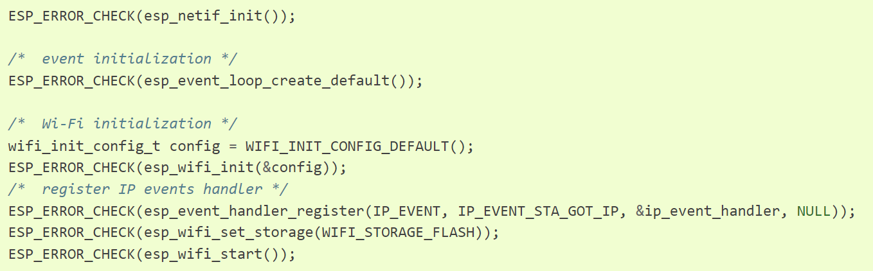

Figure 22: ESP-WIFI-MESH Application code

Once LwIP and Wi-Fi are initialized, the process of setting up an ESP-WIFI-MESH network can be summarized into three steps:

* Initializing the mesh.
* Configuring the network.
* Starting the mesh.

To initialize ESP-WIFI-MESH, use the following code:

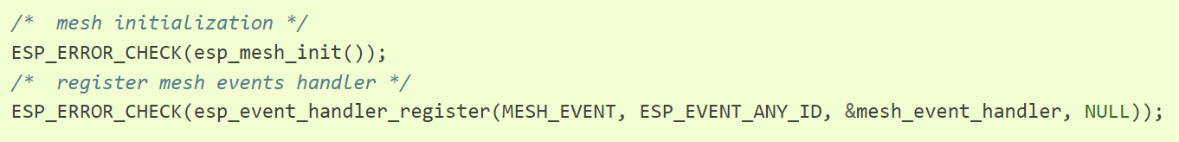

Figure 23: ESP-WIFI-MESH Initialize Mesh

ESP-WIFI-MESH configuration is achieved through **esp_mesh_set_config()**, which takes arguments provided by the **mesh_cfg_t** structure. This structure contains parameters used to configure ESP-WIFI-MESH, including:

|  |  |
| --- | --- |
| Parameter | Description |
| Channel | Range from 1 to 14 |
| Mesh ID | ID of mesh network |
| Router | Router configuration |
| Mesh AP | Mesh AP configuration |
| Crypto Function | Crypto Functions for Mesh IE |

The code snippet below demonstrates how to configure ESP-WIFI-MESH:

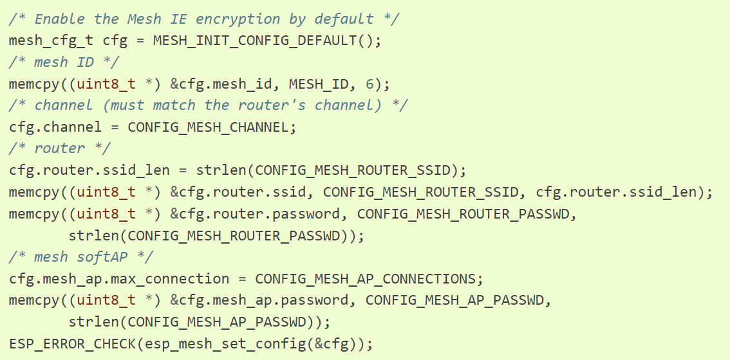

Figure 24: ESP-WIFI-MESH Netwrok Configuration

To start ESP-WIFI-MESH, use the following code:

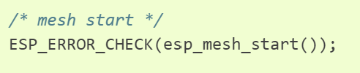

Figure 25: ESP-WIFI-MESH start

Once ESP-WIFI-MESH is started, the application should monitor ESP-WIFI-MESH events to determine when it successfully connects to the network. After establishing a connection, the application can begin transmitting and receiving packets over the ESP-WIFI-MESH network using **esp_mesh_send()** and **esp_mesh_recv()**.

3.5 TaskScheduler Library

The TaskScheduler library for Arduino allows to schedule and manage tasks to be executed at specific intervals or under certain conditions. It provides a simple interface for creating tasks and defining their execution rules.

To use the TaskScheduler library:

* Include the library.
* Create tasks and define their execution rules: Use TaskScheduler library's functions and macros to create tasks and specify when and how they should be executed.

Example that demonstrates the usage of the TaskScheduler library:

#include <TaskScheduler.h>

TaskScheduler scheduler**;**

// Task 1: Blink LED1 every 1 second

void task1**(){**

digitalWrite**(**LED1_PIN**,** **!**digitalRead**(**LED1_PIN**));**

**}**

// Task 2: Blink LED2 every 500 milliseconds

void task2**(){**

digitalWrite**(**LED2_PIN**,** **!**digitalRead**(**LED2_PIN**));**

**}**

void setup**()** **{**

pinMode**(**LED1_PIN**,** OUTPUT**);**

pinMode**(**LED2_PIN**,** OUTPUT**);**

scheduler**.**init**();**

// Add Task 1 to the scheduler with an interval of 1000 milliseconds

scheduler**.**addTask**(**task1**,** 1000**);**

// Add Task 2 to the scheduler with an interval of 500 milliseconds

scheduler**.**addTask**(**task2**,** 500**);**

// Enable all tasks in the scheduler

scheduler**.**enableAll**();**

**}**

void loop**()** **{**

// Run the scheduler to execute enabled tasks

scheduler**.**execute**();**

**}**

In this example, we include the TaskScheduler library and create an instance of the TaskScheduler object named scheduler. We define two tasks- task1 and task2 which toggle the states of led1_pin and led2_pin respectively. Then we initialize the scheduler and add the tasks with their respective intervals. Finally, in the loop() function we run the scheduler to execute the enabled tasks.

3.6 Json Format

JSON (JavaScript Object Notation) is a lightweight data interchange format that is easy for humans to read and write, and easy for machines to parse and generate. It is widely used for data serialization and communication between web services, applications and IoT devices.

JSON data is represented as key-value pairs and organized into a structured format. There are some basic elements in JSON such as, Objects, Arrays, Strings, Numbers, Booleans, Null.

Chapter 4: Results

4.1 Image Results

תוצאות של תמונות -

4.2 Resize packets

In this test, we changed the size of the package in each iteration (from 1000 bits to 1500 bits in increments of 100 bits) and sent it 100 times in a row.

That is, we wanted to check the effect of the packet size on the percentage of receiving packets on the server.

The result of this test is as shown below:

4.3 Alerts Results

We performed 3 main tests, in test#1, we initiate with a fundamental structure, consisting of one master node and a solitary client node, both tethered to a server node. Here, we observe the library's performance in a simplified environment, laying the groundwork for our subsequent examinations. As the journey unfolds, we move to test#2, expanding our network to encompass two client nodes while maintaining the master and server nodes. This extension paves the way for insights into the library's adaptability to heightened interaction levels.

The pinnacle of our exploration lies in test#3, where we orchestrate an intricate symphony of nodes - one master node, three client nodes, and a central server node. This configuration underscores the library's resilience, as it navigates the complexities of an increasingly intricate network structure.

1. One master, 1 client with server:

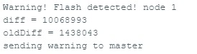

Figure 28: client#1

The client detects a change in light intensity, then sends an alert to the master

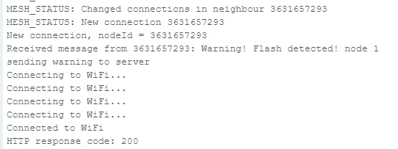

Figure 28: master

The master receives a message from client#1, connects to Wi-Fi and send this message to the server

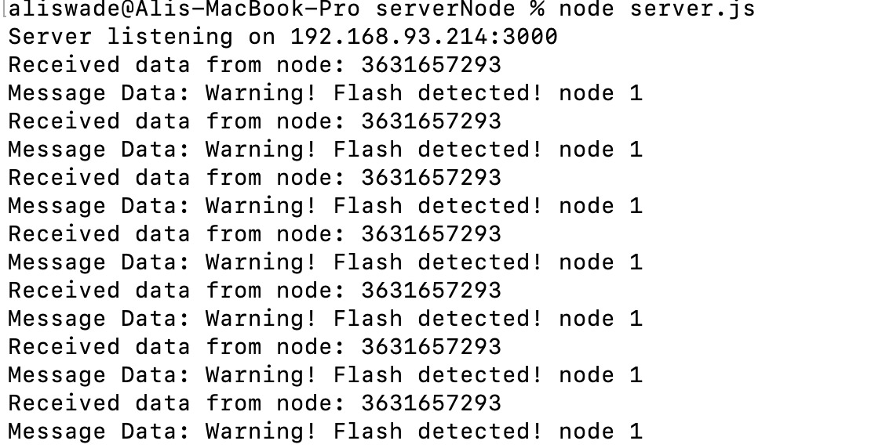

Figure 28: Server

Server Output

2. One master, 1 client with server:

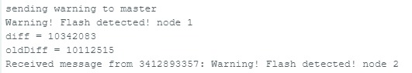

Figure 31: client #1

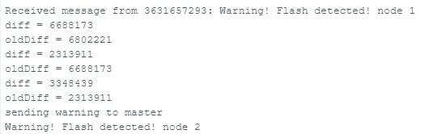

Figure 31: client #2

client#1 receives an alert from client#2 (since client#2 sends alerts by broadcast), client#1 and client#2 send to the masters an alerts

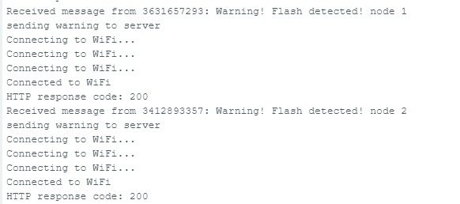

The master receives alerts from client#1 and client#2, connects to Wi-Fi and send the alerts to the Server.

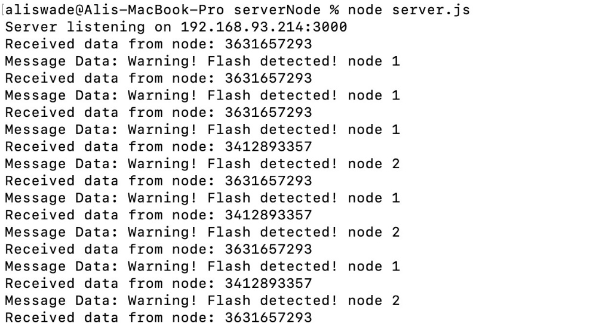

Figure 31: Server

Server Output

Figure 32: master

3. One master, 3 clients with server:

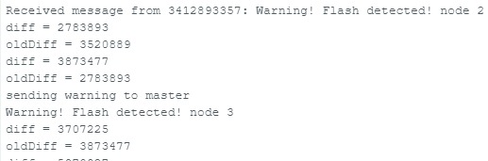

Figure 35: client #3

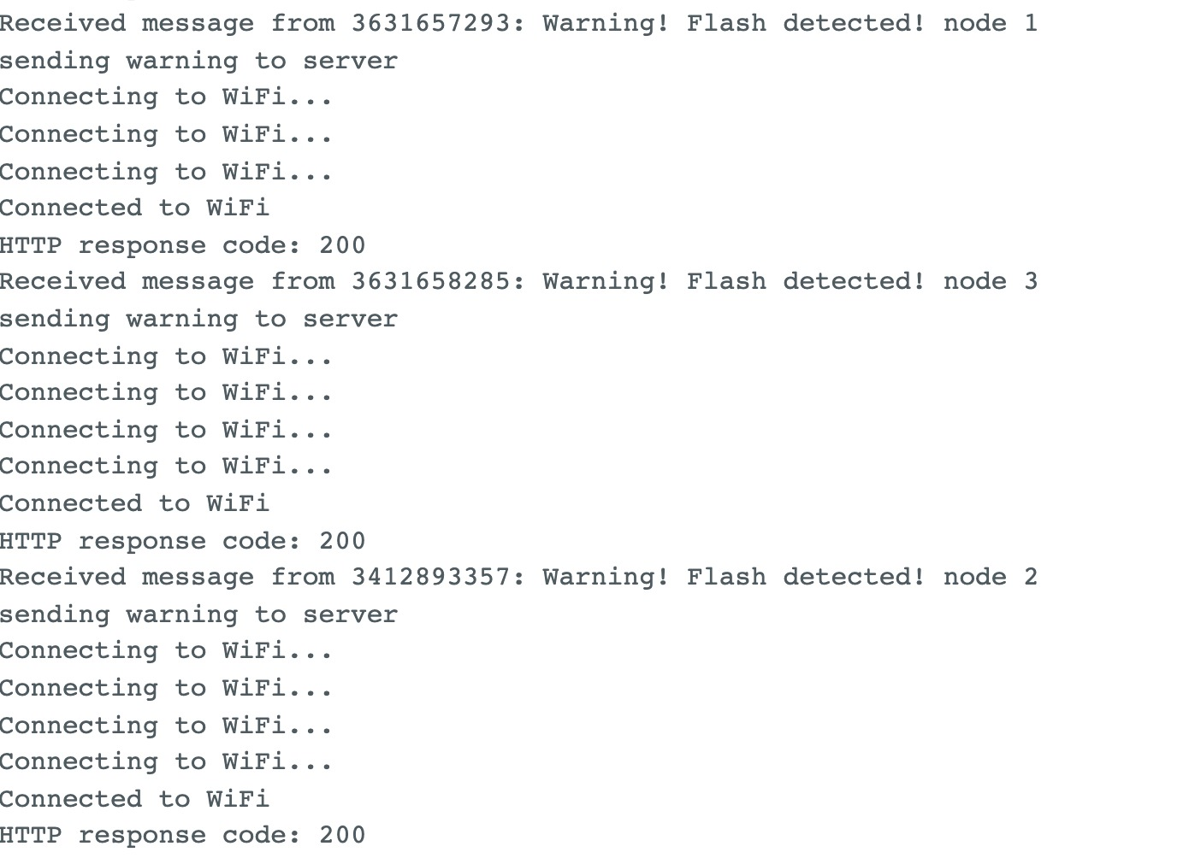

Figure 35: master

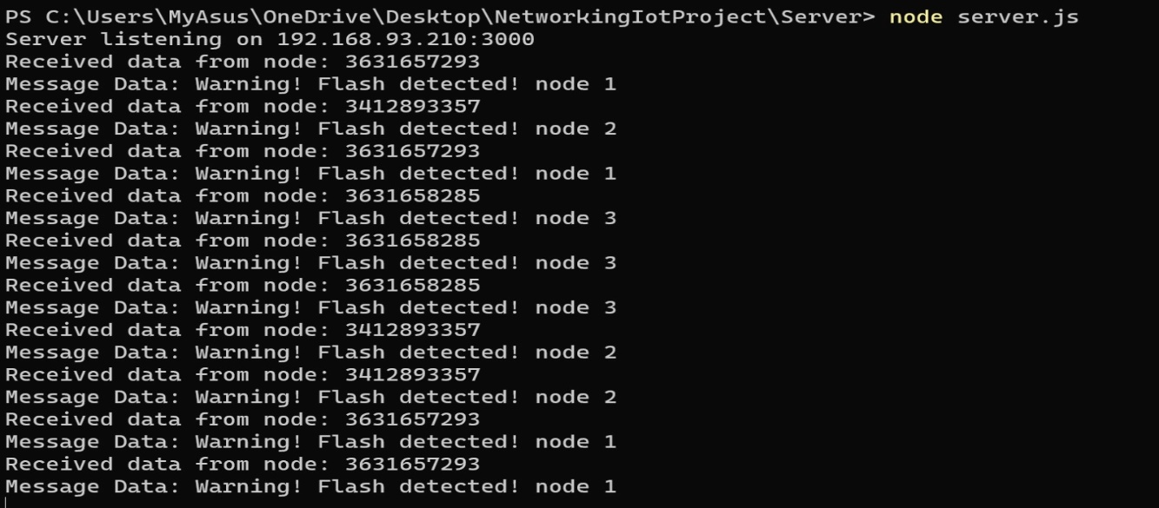

Figure 35: Server

Chapter 5: Warning Test Implementation

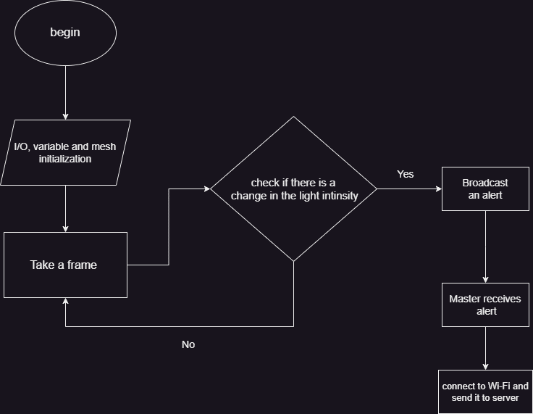

Figure 36: Software Flow Chart

Light intensity changes detection algorithm (Client Side):

int diff **=** 0**;**

**for** **(**int i **=** 0**;** i **<** fb**->**len**;** i **+=** 2**)** **{**

diff **+=** abs**((**int**)**fb**->**buf**[**i**]** **-** **(**int**)**fb**->**buf**[**i **+** 2**]);**

**}**

Serial**.**printf**(**"diff = %d\n"**,** diff**);**

Serial**.**printf**(**"oldDiff = %d\n"**,** oldDiff**);**

// Add your logic here to trigger a warning message based on the flash detection

bool triggerWarning **=** **(**diff **-** oldDiff **>** FLASH_DIFF**);** // Adjust FLASH_THRESHOLD as needed

**if** **(**triggerWarning**)** **{**

String message **=** "Warning! Flash detected! node 1 "**;**

sendMessage**(**message**);** // Send the warning message to all nodes in the network

Serial**.**println**(**message**);**

**}**

oldDiff **=** diff**;**

esp_camera_fb_return**(**fb**);** // Release the camera frame buffer

**}**

void sendMessage**(**const String**&** message**)** **{**

Serial**.**println**(**"sending warning to master"**);**

mesh**.**sendBroadcast**(**message**);**

**}**

Sends alerts to server (master Side) using http protocol:

void sendMsgToServer**(**uint32_t nodeId**,** const String**&** msg**)** **{**

WiFi**.**begin**(**ssid**,** password**);**

**do** **{**

delay**(**1000**);**

Serial**.**println**(**"Connecting to WiFi..."**);**

//mesh.update();

**}** **while** **(**WiFi**.**status**()** **!=** WL_CONNECTED**)** **;**

**if** **(**WiFi**.**status**()** **==** WL_CONNECTED**){**

Serial**.**println**(**"Connected to WiFi"**);**

HTTPClient http**;**

http**.**begin**(**serverUrl**);**

// Create a JSON payload with node ID and message data

DynamicJsonDocument data**(**128**);**

data**[**"node_id"**]** **=** String**(**nodeId**);**

data**[**"msg_data"**]** **=** msg**;**

String dataStr**;**

serializeJson**(**data**,** dataStr**);**

http**.**addHeader**(**"Content-Type"**,** "application/json"**);**

int httpResponseCode **=** http**.**POST**(**dataStr**);**

**if** **(**httpResponseCode **>** 0**)** **{**

Serial**.**print**(**"HTTP response code: "**);**

Serial**.**println**(**httpResponseCode**);**

hello_sended **=** **true;**

**}** **else** **{**

Serial**.**println**(**"Error sending message to server"**);**

**}**

http**.**end**();**

//WiFi.disconnect();

//Serial.println("Wi-Fi disconnected");

**}**

**}**

Server code using java script:

**const** express **=** require**(**'express'**);**

**const** bodyParser **=** require**(**'body-parser'**);**

**const** app **=** express**();**

app**.**use**(**bodyParser**.**json**());**

**const** ipAddress **=** '192.168.93.210'**;** // Replace with the desired IP address

**const** port **=** 3000**;** // Specify the port number

// Route to handle the POST request from the master node

app**.**post**(**'/receive-data'**,** **(**req**,** res**)** **=>** **{**

**const** receivedData **=** req**.**body**;**

console**.**log**(**'Received data from node:'**,** receivedData**.**node_id**);**

console**.**log**(**'Message Data:'**,** receivedData**.**msg_data**);**

// You can perform any further processing or store the data in a database here

res**.**sendStatus**(**200**);** // Send a success response

**});**

// Start the server

app**.**listen**(**port**,** ipAddress**,** **()** **=>** **{**

console**.**log**(**`Server listening on ${ipAddress}:${port}`**);**

**});**

Chapter 6: Conclusion

In the culmination of our project, it becomes evident that utilizing ESP components for real-time fire detection and image transmission presents substantial challenges. The practicality of sending images in real time is hindered by the inherent limitations of the ESP hardware. With images composed of 120,000 pixels, the need to segment them into smaller 2,500-pixel packets results in a sequence of 48 packets per image. However, our project's exploration, as discussed in Chapter 4.2, reveals that the ESP components' capabilities pose a barrier to executing this packet sequence smoothly.

In light of these findings, a clear recommendation emerges: considering the current constraints, deploying ESP components for real-time fire detection and image transmission is not a viable solution. The project underscores the importance of aligning application demands with hardware capabilities and the need for pragmatic decisions when integrating advanced technologies into practical applications. This project contributes not only insights into ESP components but also a broader understanding of the intricate interplay between technology aspirations and hardware realities.

Chapter 7: Suggestions to improvement

* **Enhancing Fire Detection Algorithm:** The algorithm we implemented only detects a change in the light intensity of the camera so that it may warn of irrelevant things, it is possible to improve the algorithm that will analyze an image and detect fires.
* Send images in real time with high resolution and informative.

טיוטה של תוצאות:

הערה השליחה מה client ל master מתבצעת ב broadcast . החיפוש כדי למצוא את ה root ואז שליחת ההודעה ב sendsingle לקח זמן ושיביש את העברת החבילות.

עבור שליחת 10 הודעות “hello from client!{num}” מה client ל master עם דלאיי של 5 שניות ואז לשרת אזי קיבלנו בשרת את ההודעות 0,1,7,8 , ההתחברות ל wifi במאסטר כדי לשלוח לשרת מעקבת את המאסטר ולכן לא מקבל את כל ההודעות מה client (ללא השליחה לשרת המאסטר קיבל את כל ההודעות מה client ).

ה client שולח במרווחי זמן של שניה ובמאסטר מכניסים את ההודעות לוקטור ואז מטפלים בהם כאשר הוקטור בגודל של 10 (המאסטר קיבל 10 הודעות מהלקוח):אז, המאסטר קיבל את 10 ההודעות אגר אות בוקטור ושלח אותם לשרת לכל הודעה הוא התחבר ל wifi ואז שלח אותה לשרת, כולם הגיעו לשרת אך החיבור ל wifi לקח זמן.

ננסה להתחבר פעם אחת לwifi ואז לשלוח את 10 ההודעות בבת אחת לשרת: הגיעו 10 ההודעות לשרת באופן מהיר יותר ☺

ננסה לשלוח 100 הודעת: שליחה עם דליי של שניה לא כל ההודעת הגיעו למאסטר

הקטנו את הדליאי ל חצי שניה בין הודעה להודעה ואז 100 הודעות הגיעו למאסטר ומהמאסטר לשרת ☺

200 הודעות עם דילאיי של 0.01 שניה: 200 הודעות הגיעו למאסטר ולשרת ☺

500 הודעות עם דילאיי 0.01 שניה: כבר קרו בעיות, המאסטר מקבל עד 255 כזה ואז חוזר לקבל הודעות התחלתיות 0,1,2,3.. עד 243 (כאילו קיבל אותם כשתי יחידות) ואז לשרת מקבל הודעות מספר פעמים, ולא לפי הסדר, הלקוח חוזר לשלוח הודעות שוב למרות ששלח מקודם (כאילו עשה reset ). מסקנה כנראה הלקוח יוכל לשולח עד 255 הודעות ברצף.

300 הודעות: גם כאן הלקוח מנסה לשלוח עד 300 לא מצליח ולכן חוזר שוב ושוב.

255: כן הצליח לשלוח למאסטר ומהמאסטר לשרת ☺

טסט לבדיקת גודל חבילה מקסימלי ש esp32cam יכול לשלוח:

שליחת חביולת בגדלים של 1,2,4,8,16... עד 4096 בדליי של שניה בין הודעה להודעה, אזי כל ההודעות הגיעו למאסטר וגם לשרת.

עד 32768 אזי התעבורה השתבשה, לא כולן הגיעו למאסטר (רק קיבל עד 512)

ואז התחיל לקבלהודעות לא נכונות שלקוח שלח.

הקטנת הדליי בין השליחה ל 0.1 שניה התקבל במאסטר עד 8192 ואז השתבשה התעבורה, הלקוח שולח הודות שגויות (בגודל שונה)

נקטין ל 0.01 דילאיי: עדיין אותן תוצאות

זהו עד 8192 מקבל ומעביר לשרת כהלכה.